Ideation Phase Empathize & Discover

Date | 06-03-2026
Team ID | LTVIP2026TMIDS48993
Project Name | ToyCraft tales: tableau's vision into toy manufacturer data
Maximum Marks | 4 Marks

Empathy Map Canvas:
An empathy map is a simple, easy-to-digest visual that captures knowledge about a user’s behaviours and attitudes.

It is a useful tool to helps teams better understand their users.
Creating an effective solution requires understanding the true problem and the person who is experiencing it. The exercise of creating the map helps participants consider things from the user’s perspective along with his or her goals and challenges.

Example:

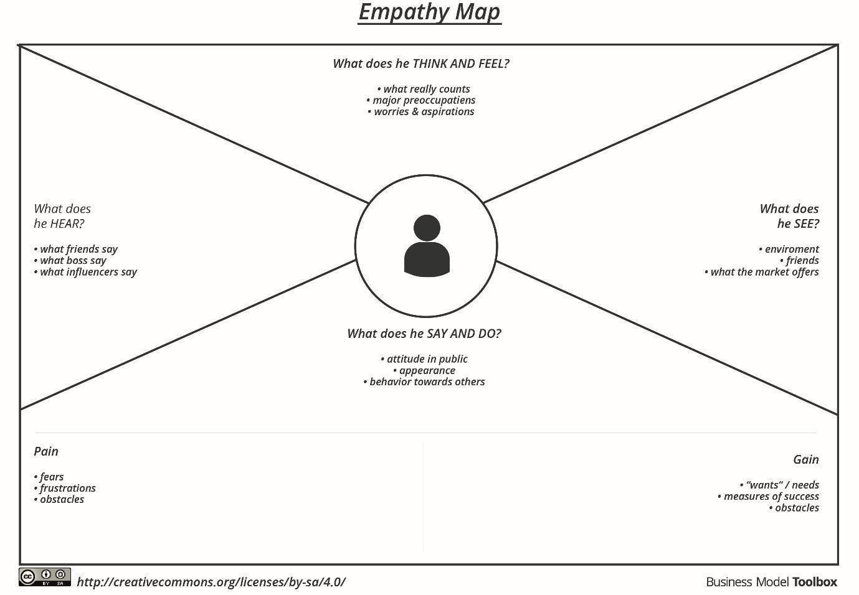

Electrical Consumption in India Exploring Patterns: Empathy Map

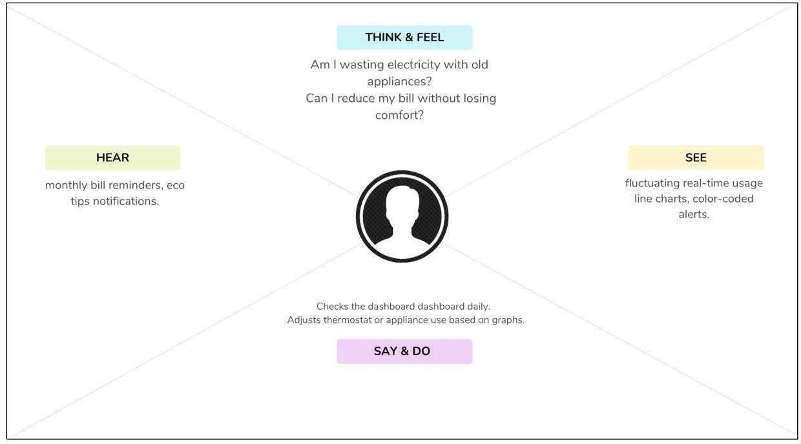

Our empathy map centres on the end-user of the electrical dashboard — typically a homeowner or facility manager who wants greater visibility into their energy consumption.

The map explores their thoughts, feelings, actions, and surroundings to ensure the dashboard addresses their real-world pain points and aspirations.

Says:
The user expresses a desire for transparency and control — they want to monitor their energy usage in real time and understand why spikes occur.

Thinks:
Internally, the user is concerned about efficiency and costs. They’re curious whether old appliances or habits cause unnecessary energy consumption and are looking for actionable ways to reduce their bills.

Does:
They check the dashboard regularly, make small adjustments to appliances or settings, and look at past usage trends to plan their future behaviour.

Feels:
They may feel frustrated when seeing unexplained surges or worried about overspending, but also empowered when they achieve energy savings or receive helpful alerts.

Sees & Hears:
The user observes real-time graphs, visual cues (color-coded thresholds), and occasional notifications, all of which help them make better decisions about their energy usage.

